**DESIGN AND ANALYSIS OF HF ANTENNA SYSTEMS**

Department of Electronics and Communication Engineering  
Date: September 16, 2025

**EXECUTIVE SUMMARY**

This report presents a comprehensive analysis of **High Frequency (HF) antenna** systems operating in the 3-30 MHz band, covering fundamental design principles, propagation characteristics, and practical applications. HF antennas utilize **ionospheric propagation** to achieve intercontinental communication distances, making them essential for maritime, aviation, emergency, and amateur radio services. The analysis demonstrates that well-designed HF systems can achieve **global communication** coverage with relatively modest power levels through skywave propagation.[1][2][3][4]

**1. INTRODUCTION**

**1.1 HF Band Definition**

The **High Frequency band** spans 3-30 MHz, corresponding to wavelengths from 100 meters down to 10 meters. This frequency range enables unique propagation characteristics that distinguish HF from other radio services.[2][4]

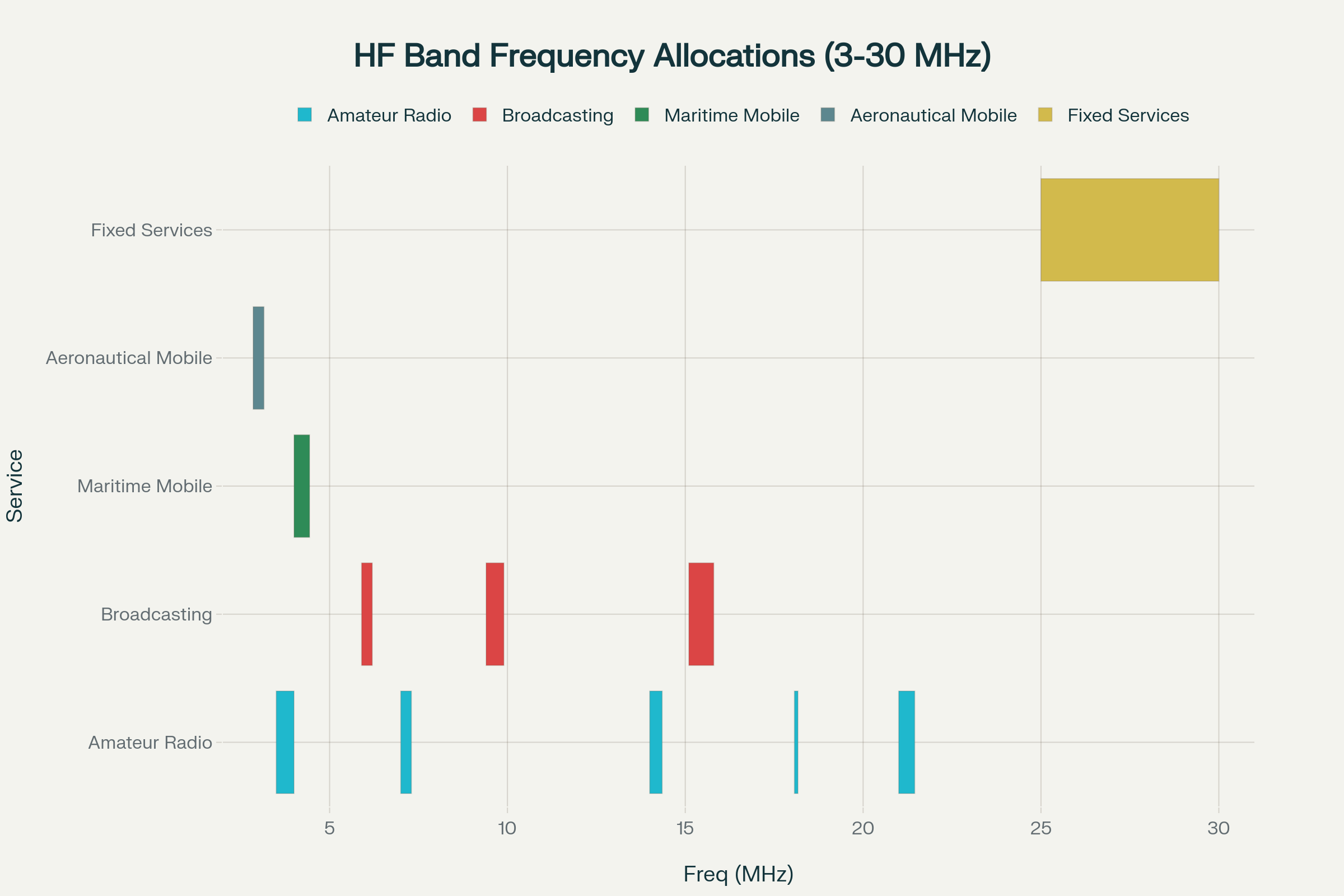

Figure 1 – HF frequency band allocations (3-30 MHz) for various radio services.

**1.2 Propagation Mechanisms**

HF waves utilize **skywave propagation**, where radio signals reflect off ionospheric layers to achieve beyond-line-of-sight communication. This mechanism enables intercontinental distances of thousands of kilometers with modest transmitter power.[2][3]

**1.3 Applications**

HF systems serve **maritime communications**, aviation services, emergency networks, amateur radio, and international broadcasting. Military and diplomatic communications also rely heavily on HF capabilities.[1][5][6]

**2. HF PROPAGATION THEORY**

**2.1 Ionospheric Layers**

The ionosphere consists of **D, E, and F layers** at different altitudes, each affecting HF propagation differently. The F-layer provides the primary reflection mechanism for long-distance HF communication.[2][3]

**2.2 Diurnal Variations**

HF propagation exhibits **strong daily cycles** driven by solar radiation effects on ionospheric density. Daytime conditions favor higher frequencies while nighttime propagation shifts to lower frequencies.[2][3]

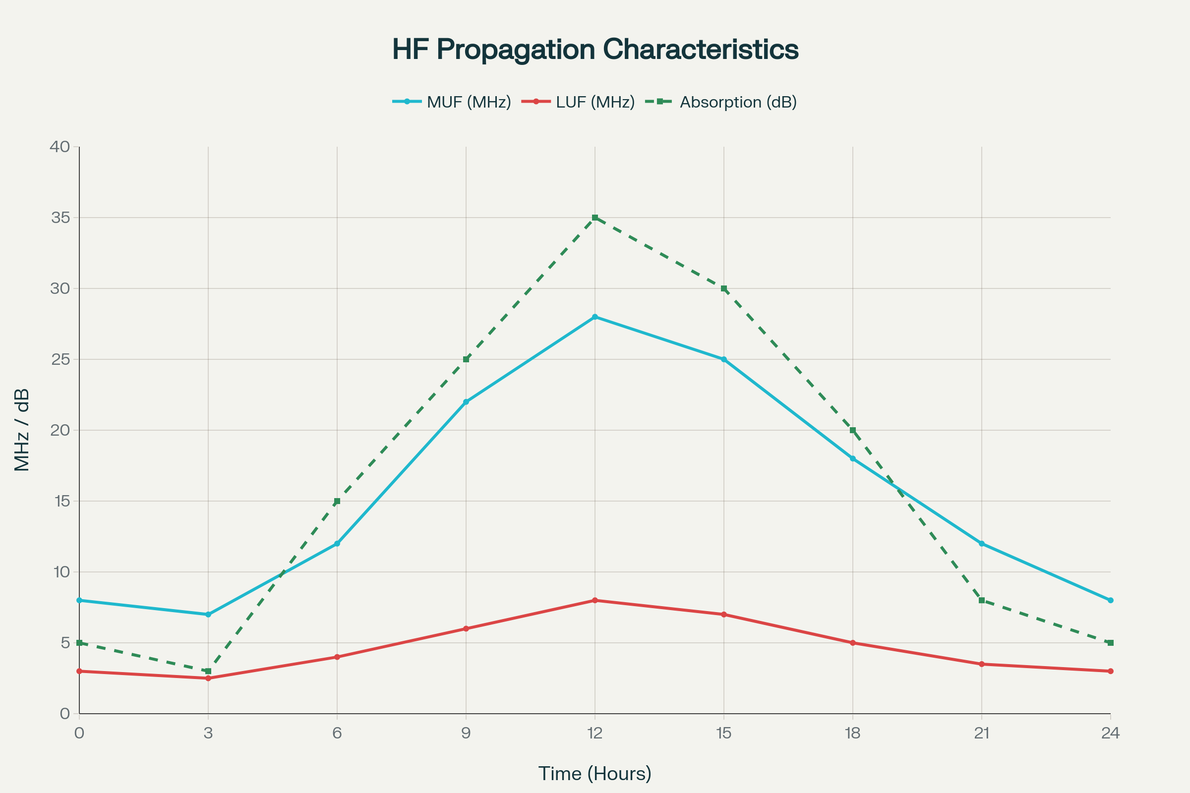

Figure 3 – Diurnal variation of HF propagation parameters showing MUF, LUF, and D-layer absorption.

**2.3 Critical Parameters**

Key propagation parameters include **Maximum Usable Frequency (MUF)**, **Lowest Usable Frequency (LUF)**, and **Frequency of Optimum Transmission (FOT)**. These parameters define the usable frequency window for specific propagation paths.[2][7]

**3. DIPOLE ANTENNA FUNDAMENTALS**

**3.1 Basic Dipole Theory**

The **half-wave dipole** represents the fundamental HF antenna, exhibiting resonant behavior when its length equals λ/2. Input impedance approaches 73 ohms at resonance, providing good matching to standard transmission lines.[8][9]

**3.2 Radiation Characteristics**

Dipole antennas produce **omnidirectional patterns** in the azimuth plane with maximum radiation perpendicular to the wire axis. The radiation pattern exhibits characteristic nulls along the antenna axis.[8][9][10][11]

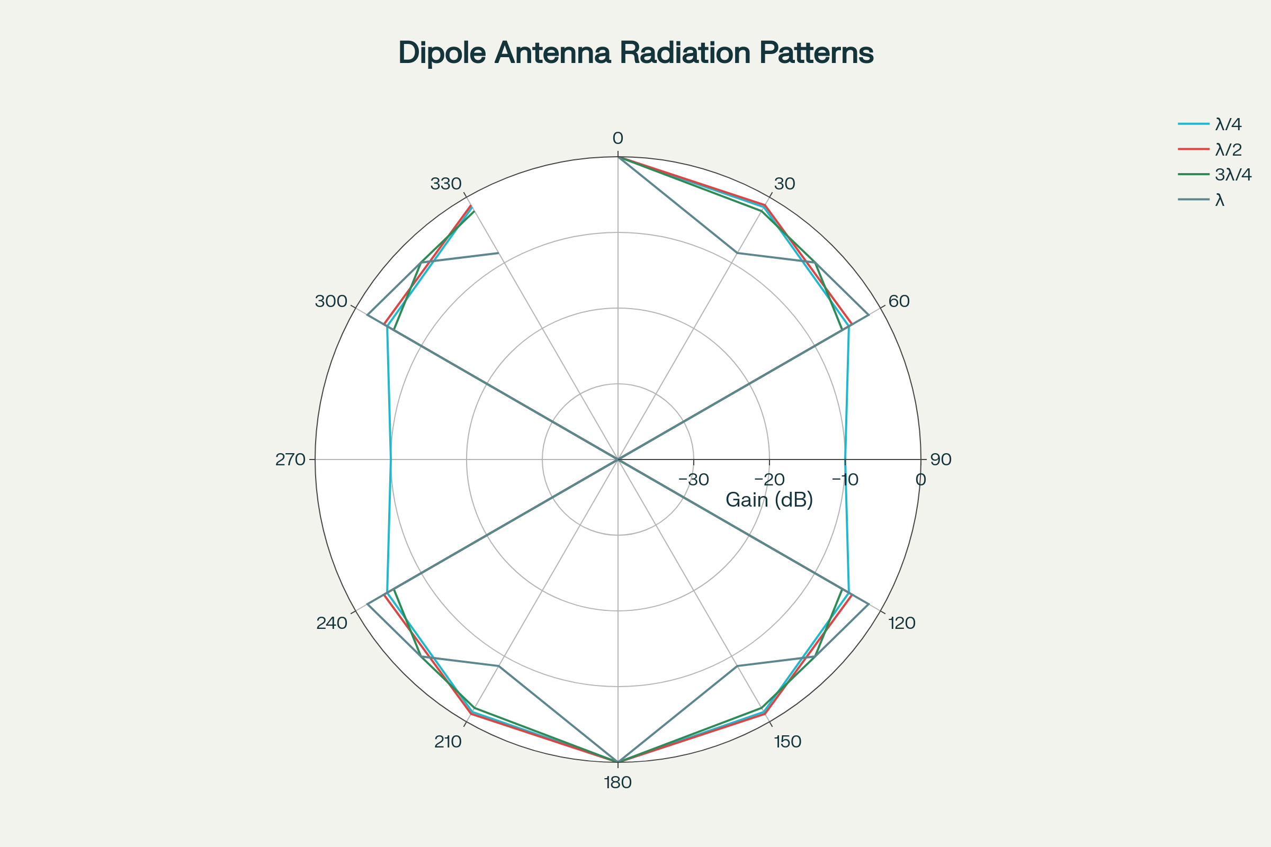

Figure 2 – Radiation patterns for dipole antennas of different electrical lengths.

**3.3 Length Effects**

**Electrical length** significantly affects radiation patterns, with longer antennas developing multiple lobes and higher directivity. Quarter-wave verticals provide different characteristics compared to half-wave horizontal dipoles.[8][9]

**4. HF ANTENNA TYPES**

**4.1 Vertical Antennas**

**Monopole configurations** including whip antennas and loaded verticals provide compact solutions for mobile and maritime applications. Ground plane quality critically affects vertical antenna performance.[12]

**4.2 Horizontal Wire Antennas**

**Dipole and doublet** configurations offer effective solutions for fixed installations. Inverted-V and sloper configurations adapt to space-constrained installations.[13][5]

**4.3 Log-Periodic Antennas**

**Frequency-independent designs** provide broadband operation across the entire HF spectrum. Log-periodic antennas offer consistent gain and pattern characteristics across wide frequency ranges.[14]

**4.4 Loop Antennas**

**Magnetic loop** configurations enable compact HF antennas with directional capabilities. Small loops require high-Q tuning systems but offer excellent portability.[15]

**5. DESIGN CONSIDERATIONS**

**5.1 Antenna Matching**

**Impedance transformation** becomes critical for efficient power transfer in HF systems. Antenna tuning units (ATUs) enable operation across wide frequency ranges with fixed antenna geometries.[12]

**5.2 Ground Systems**

**Radial networks** and counterpoise systems significantly affect vertical antenna performance. Poor ground systems cause efficiency losses and pattern distortion.[12]

**5.3 Environmental Factors**

**Soil conductivity**, nearby objects, and installation height affect antenna performance. Coastal locations with high ground conductivity favor HF propagation.[2][4]

**6. BROADBAND HF ANTENNAS**

**6.1 Loaded Antennas**

**Inductive and capacitive loading** enables electrically short antennas to operate efficiently across HF bands. Loading techniques trade bandwidth for size reduction.[13][5]

**6.2 Multi-Wire Designs**

**Cage and fan dipoles** increase bandwidth through multiple parallel conductors. These designs provide broader frequency coverage with acceptable efficiency.[1][5]

**6.3 Folded Dipoles**

**Transmission line principles** applied to folded configurations provide impedance transformation and increased bandwidth. Folded dipoles offer 4:1 impedance step-up compared to simple dipoles.[13]

**7. PROPAGATION PATH ANALYSIS**

**7.1 Skip Zone Characteristics**

**Ground wave** and **skywave** propagation create zones of signal strength variation. The skip zone represents an area where neither propagation mode provides adequate signal levels.[2][4]

**7.2 Multi-Hop Propagation**

**Multiple ionospheric reflections** enable global communication through successive hops. Each reflection introduces losses and signal dispersion.[2][3]

**7.3 Polarization Effects**

**Faraday rotation** in the ionosphere affects wave polarization, particularly at lower HF frequencies. Circular polarization antennas can mitigate polarization-dependent fading.[1][3]

**8. ANTENNA MODELING AND SIMULATION**

**8.1 Electromagnetic Analysis**

**Method of Moments** and **Finite Element** techniques enable accurate antenna performance prediction. Ground effects require sophisticated modeling approaches.[6]

**8.2 Pattern Optimization**

**Genetic algorithms** and optimization techniques improve antenna designs for specific requirements. Multi-objective optimization balances gain, bandwidth, and size constraints.[6]

**8.3 Installation Effects**

**Site-specific modeling** accounts for local terrain and structures affecting antenna performance. Computational tools enable pre-installation performance prediction.[6]

**9. MEASUREMENT TECHNIQUES**

**9.1 Antenna Analyzers**

**Vector impedance** measurements characterize antenna resonance and bandwidth. Field strength meters verify radiation efficiency and pattern shape.[12]

**9.2 On-Air Testing**

**Signal reports** and propagation logging provide real-world performance verification. Beacon stations enable systematic propagation studies.[2][7]

**9.3 Pattern Measurements**

**Field intensity** measurements at various angles characterize radiation patterns. Elevated ranges minimize ground reflection effects during testing.[10]

**10. PRACTICAL APPLICATIONS**

**10.1 Maritime Communications**

**Ship-to-shore** and **ship-to-ship** communication relies on HF for global coverage. Automatic link establishment (ALE) systems optimize frequency selection.[1][12]

**10.2 Aviation Services**

**Long-range aircraft** communication over oceanic routes depends on HF systems. Selective calling and data link capabilities enhance operational efficiency.[2]

**10.3 Emergency Networks**

**Disaster communications** utilize HF when terrestrial infrastructure fails. Portable and emergency-powered HF stations provide crucial communication links.[2]

**10.4 Amateur Radio**

**Worldwide communication** through amateur radio networks demonstrates HF capabilities. Contest operations and emergency service provide operational experience.[5]

**11. SYSTEM PERFORMANCE METRICS**

**11.1 Efficiency Factors**

**Radiation efficiency** depends on antenna design, ground systems, and environmental factors. Typical HF antenna efficiencies range from 10% to 95% depending on configuration.[12][9]

**11.2 Bandwidth Characteristics**

**SWR bandwidth** defines the frequency range for acceptable impedance matching. Most HF antennas exhibit narrow bandwidth requiring tuning or matching networks.[13][12]

**11.3 Gain and Directivity**

**Antenna gain** varies from -1 dBi for small loops to +15 dBi for large arrays. Directional antennas provide spatial discrimination capabilities.[14][9]

**12. COMPARATIVE ANALYSIS**

|  |  |  |  |  |  |
| --- | --- | --- | --- | --- | --- |
| Antenna Type | Gain (dBi) | Bandwidth | Size | Complexity | Applications |
| **Half-Wave Dipole** | 2.1 | Narrow | Medium | Low | General Purpose |
| **Vertical Whip** | 0-3 | Narrow | Compact | Low | Mobile/Maritime |
| **Log-Periodic** | 6-9 | Very Wide | Large | Medium | Broadband |
| **Magnetic Loop** | -5 to +2 | Very Narrow | Compact | High | Portable |
| **Rhombic** | 10-15 | Wide | Very Large | Medium | Point-to-Point |

*Table 1: HF antenna performance comparison*[14][12][9]

**13. ADVANCED TECHNIQUES**

**13.1 Adaptive Systems**

**Computer-controlled** matching networks automatically optimize antenna performance. Real-time impedance measurement enables dynamic tuning.[12]

**13.2 Array Configurations**

**Phased arrays** provide electronically steerable beams for enhanced communication reliability. Diversity reception systems mitigate fading effects.[6]

**13.3 Digital Signal Processing**

**Software-defined radio** techniques enhance weak signal reception and interference rejection. Digital modes optimize information transfer under challenging propagation conditions.[7]

**14. EMERGING TECHNOLOGIES**

**14.1 Smart Antennas**

**Cognitive radio** systems automatically select optimal antenna configurations and frequencies. Machine learning algorithms predict propagation conditions.[7]

**14.2 Near-Vertical Incidence Skywave**

**NVIS techniques** provide reliable regional communication through high-angle radiation. Special antenna designs optimize for NVIS propagation modes.[2]

**14.3 Meteor Scatter Enhancement**

**Meteor trail reflections** extend HF communication capabilities beyond conventional skywave limits. Burst transmission techniques exploit brief reflection periods.[2]

**15. FUTURE DEVELOPMENTS**

**15.1 Climate Effects**

**Global warming** impacts on ionospheric behavior may alter HF propagation characteristics. Long-term studies monitor propagation changes.[3][7]

**15.2 Solar Cycle Variations**

**11-year solar cycles** significantly affect HF propagation capabilities. Prediction models help optimize system design for varying solar activity.[2][7]

**15.3 Space Weather**

**Geomagnetic storms** and solar flares can disrupt HF communications. Robust system design accounts for space weather effects.[2][3]

**16. CONCLUSION**

HF antenna systems remain **fundamentally important** for long-distance communication, emergency services, and specialized applications where satellite alternatives are unavailable or inadequate. The unique combination of global coverage capability and relatively simple infrastructure makes HF technology irreplaceable for many applications.[2][3][4]

Success in HF antenna design requires **comprehensive understanding** of ionospheric propagation, antenna theory, and practical engineering constraints. Modern computational tools and adaptive techniques continue expanding HF system capabilities while maintaining the inherent advantages of skywave propagation.[6][9][7][2]

Future developments in **space weather prediction**, **adaptive antenna systems**, and **digital signal processing** will enhance HF communication reliability and efficiency. The enduring value of HF systems ensures continued innovation in antenna design and propagation techniques.[3][7][2]

**REFERENCES**

1. <https://www.antennas.com/product/ht-30/>

1. <https://en.wikipedia.org/wiki/High_frequency>

1. <https://pubmed.ncbi.nlm.nih.gov/39759326/>

1. <https://electronicsdesk.com/propagation-characteristics-of-radio-waves.html>

1. <https://www.npcwireless.in/products/3-wire-hf-antenna-2-mhz-to-30-mhz>

1. <https://asset.library.wisc.edu/1711.dl/GF36VTNFH3G6A87/R/file-8853a.pdf>

1. <https://agupubs.onlinelibrary.wiley.com/doi/abs/10.1029/2023RS007657>

1. <https://www.antenna-theory.com/antennas/dipole.php>

1. <https://en.wikipedia.org/wiki/Dipole_antenna>

1. <https://www.electronics-notes.com/articles/antennas-propagation/dipole-antenna/radiation-pattern-directivity.php>

1. <https://jemengineering.com/blog-dipoles/>

1. <https://amphenolprocom.com/products/base-station-antennas/produkter/399-hf-7500-3>

1. <https://www.antennaexperts.in/product-detail.asp?id=13>

1. <https://www.antennas.com/product/spr-330/>

1. <https://web.iitd.ac.in/~debanjan/RadiationpatternDipoleLoop.pdf>

1. <https://www.sciencedirect.com/science/article/pii/S2405844024169940>

1. <https://www.elprocus.com/dipole-antenna/>

1. <https://www.itu.int/dms_pubrec/itu-r/rec/p/R-REC-P.1060-0-199408-I>!!PDF-E.pdf

1. <https://www.industrialnetworking.com/pdf/Antenna-Patterns.pdf>

1. <https://en.wikipedia.org/wiki/Very_high_frequency>